Mail Delivery Agent (MDA)
# Source: AI Source: Provided by: [Data Path: Persons Table -> ID Column: 1, Name_En Column: Motasem Essam] -> From: [Chatgpt (GPT‑5 Mini)] on [1/21/2026]
A Mail Delivery Agent (MDA) is a program that receives email messages from a Mail Transfer Agent (MTA) and delivers them to a user's mailbox.

📦 What Does an MDA Do?
# Source: AI Source: Provided by: [Data Path: Persons Table -> ID Column: 1, Name_En Column: Motasem Essam] -> From: [Chatgpt (GPT‑5 Mini)] on [1/21/2026]
- 📥 Receives incoming email (from the MTA like Postfix, Sendmail, etc.)
- 📨 Delivers it to a local mailbox (like a file or Maildir)
- 🧹 Applies filters or rules (e.g., spam filtering, sorting)

📊 Email Flow Overview
# Source: AI Source: Provided by: [Data Path: Persons Table -> ID Column: 1, Name_En Column: Motasem Essam] -> From: [Chatgpt (GPT‑5 Mini)] on [1/21/2026]
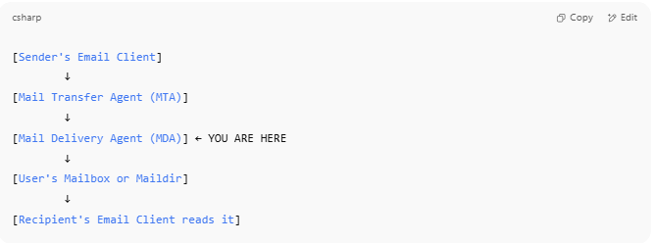

[Sender's Email Client]
↓
[Mail Transfer Agent (MTA)]
↓
[Mail Delivery Agent (MDA)] ← YOU ARE HERE
↓
[User's Mailbox or Maildir]
↓
[Recipient's Email Client reads it]

🔧 Common MDA Examples
# Source: AI Source: Provided by: [Data Path: Persons Table -> ID Column: 1, Name_En Column: Motasem Essam] -> From: [Chatgpt (GPT‑5 Mini)] on [1/21/2026]
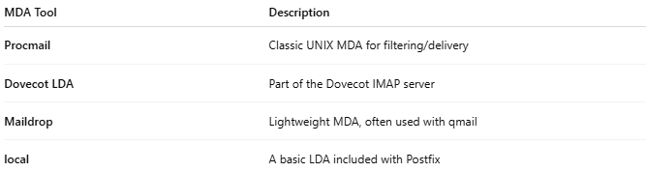

MDA Tool | Description
Procmail | Classic UNIX MDA for filtering/delivery
Dovecot LDA | Part of the Dovecot IMAP server
Maildrop | Lightweight MDA, often used with qmail
local | A basic LDA included with Postfix

🧠 How MDA Differs From MTA and MUA
# Source: AI Source: Provided by: [Data Path: Persons Table -> ID Column: 1, Name_En Column: Motasem Essam] -> From: [Chatgpt (GPT‑5 Mini)] on [1/21/2026]
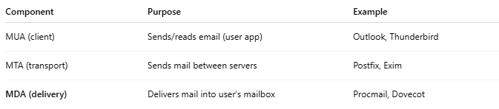

Component | Purpose | Example
MUA (client) | Sends/reads email (user app) | Outlook, Thunderbird
MTA (transport) | Sends mail between servers | Postfix, Exim
MDA (delivery) | Delivers mail into user’s mailbox | Procmail, Dovecot

✅ Summary
# Source: AI Source: Provided by: [Data Path: Persons Table -> ID Column: 1, Name_En Column: Motasem Essam] -> From: [Chatgpt (GPT‑5 Mini)] on [1/21/2026]
A Mail Delivery Agent (MDA) is the final stop in the email delivery chain — it's the tool that actually delivers the email into your mailbox, after it travels across the internet.

